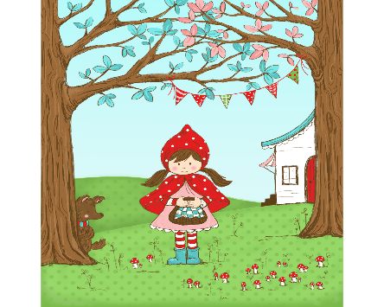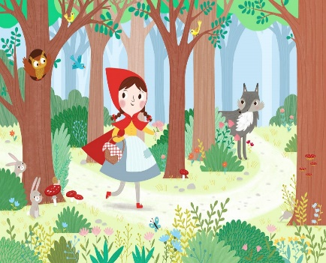 Nursery Home Learning Challenges

Little Red Riding Hood

W.C. 16.06.20

Suggested daily activities

White Rose Maths

<https://whiterosemaths.com/homelearning/>

Read, Write, Inc. Phase Two Phonics

This is especially recommended for the children starting in Reception in September. Please note that letter sound clips are uploaded daily and are only available for 24 hours.

<https://www.youtube.com/channel/UCo7fbLgY2oA_cFCIg9GdxtQ?fbclid=IwAR0x7RjPoEFwwIs6pxnl0uHxJC_CeEBupnizCnVsblLfKDQKtt1Lh1ee9lw>



Story Time

This week our learning focuses on the story ‘Little Red Riding Hood’. You can use the link below to listen to the story.

<https://www.youtube.com/watch?v=ivg_Yc-YDYo>

Joining in – can you join in with parts of the story, such as “Grandma what big eyes you have” “All the better to see you with”

Let’s talk about the story – who are the characters in the story? Where is the story set? What was the problem in the story? How is the problem solved? Do you think Little Red Riding Hood should have spoken to the wolf, why do you think that?

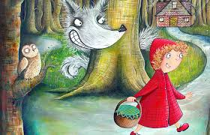

Let’s get writing

Little Red Riding Hood packs a basket of food to take to her Grandma. Can you remember why Little Red Riding Hood takes food to her Grandma?

Today we are going to write a list of things to pack inside a bag, lunchbox or basket. It might be things that you would like to have for your lunch. Your writing might have letters or it might be marks, you can talk to your grownups about what you have written. Remember, to use a pinchy parrot grip. When we write a list our words go below one another down the page. Maybe you could pack up the food on your list and have a picnic lunch in your garden.

Extension – listening to and writing the first sounds in words e.g. **a**pple and **s**andwich.

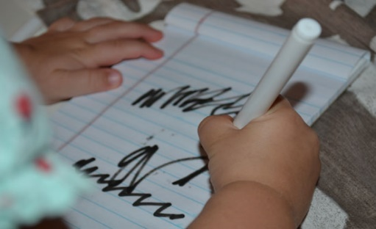

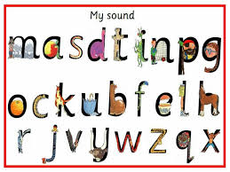

Let’s get moving!

Today we are going to get busy moving our bodies in different ways.

We are going to further explore the story of Little Red Riding Hood through fairy tale yoga.

<https://www.youtube.com/watch?v=6u5QoqgtT9w>

What happens in the story? Who are the characters? Can you remember what the characters say?

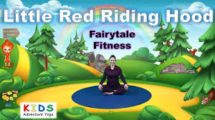

Mathematics

In the story Little Red Riding Hood goes on a walk, can you remember where Little Red Riding Hood went? I wonder what she saw in the woods.

Today can you go on a walk or in your garden? I wonder if you can find some leaves and sticks. Can you find leaves that are different shapes and sizes? Can you find sticks that are long and short? I wonder if you can sort your objects by shape, size or colour.

Can you count the objects that you have found? Which set do you have the most of / least of? Remember to use your careful pointing counting finger.

Extension – can you use the objects to explore addition, e.g. how many leaves and sticks do you have altogether? How will we find out?

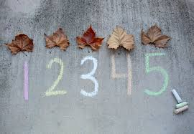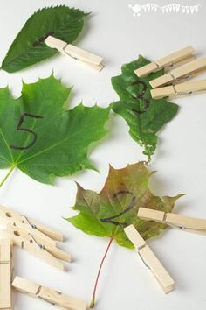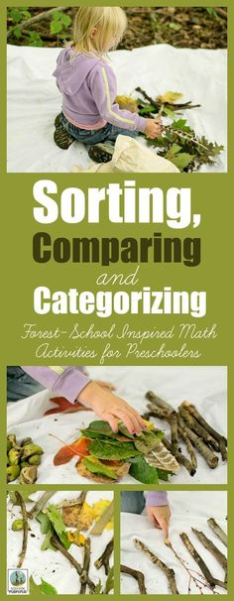

Let’s get creative

Today we are going to make our very own Red Riding Hood. I wonder what colours would be good to make Red Riding Hood. You can use anything that you have at home, you might even hunt for sticks and leaves to make a woodland background. You could use your Red Riding Hood to retell the story. We would absolutely love to see your creations.

